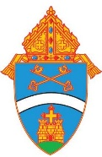

A Pastoral Guide for Prayer, Formation, and Action During National Migration Week
September 21-27, 2026

“Whoever welcomes one such child in my name welcomes me."
Matthew 18:5

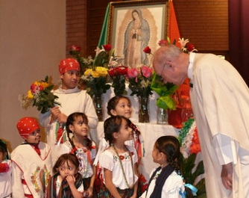

“To our immigrant brothers and sisters, we stand with you in your suffering, since, when one member suffers, all suffer (cf. 1 Corinthians 12:26).
You are not alone!”

Special Pastoral Message on Immigration United States Conference of Catholic Bishops 2025

Page | Content
1 | Cover
3 | Table of Contents
4 | Introductory statement
5 | Message of Pope Leo XIV for World Day of Migrants and Refugees 2026
6 | Message of Bishop Godfrey for National Migration Week 2026
7 | National Migration Week 2026
8 | Why Does the Church Care About Migration?
9 | Ways to Observe — Prayer & Formation
10 | Ways to Observe — Hospitality & Service
11 | Even Just One: Engaging Children & Youth
12 | Prayer Service
13 | Prayer Service — Petitions & Closing
14 | Readings, Hymns & Intercessions
15 | Intercessions / Sunday Scripture Reflections
16 | Migrant Story — Part 1
17 | Migrant Story — Part 2 + Reflection
18 | A Catholic Guide to Migration
19 | Additional Resources
20 | Prayer of Commitment

May this guide inspire our parishes, schools, ministries, and families
to become places where every person, especially every child, is
welcomed with the love of Christ.
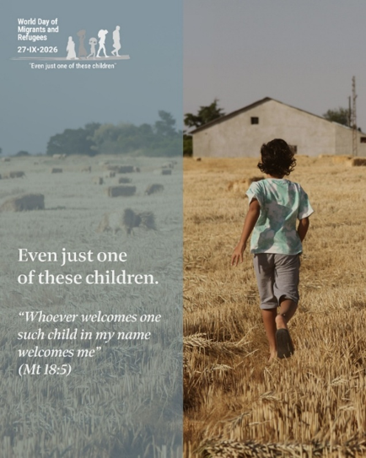

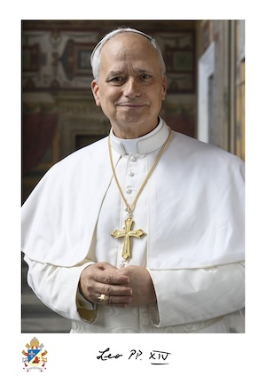
Message of Pope Leo XIV for the 112th World Day of Migrants and Refugees

“Even Just One of These Children”

“Whoever receives one such child in my name receives me.” Matthew 18:5

On September 27, 2026, the Church will celebrate the 112th World Day of Migrants and Refugees. This year, Pope Leo XIV invites us to focus especially on children and young people who experience migration and displacement. His message, “Even Just One of These Children,” reminds us that behind the numbers and statistics are real children, each with a unique story, dignity, hopes and dreams.
The Holy Father calls us to see every migrant child first as a person created in the image and likeness of God. Their vulnerability calls us to open our eyes and hearts, to listen to their stories, and to protect their fundamental dignity and rights. We are reminded that Jesus identifies himself with the vulnerable: “Whoever receives one such child in my name receives me.”
Pope Leo also challenges the Church to make welcome more than an idea. He calls Christian communities to become places where migrants and refugees are recognized as full members of the ecclesial family, where children and young people are protected from isolation and rejection, and where opportunities for friendship, encounter and integration can flourish.
His message is ultimately an invitation to move from indifference to compassion, from compassion to welcome, and from welcome to concrete action. Even just one of these children matters. Each one calls us to recognize Christ in our midst and to respond with the love, dignity and solidarity that the Gospel demands.

Read the Full Message
The complete message of Pope Leo XIV for the 112th World Day of Migrants and Refugees is available from the Holy See:
Read “Even Just One of These Children” — Pope Leo XIV
From the Vatican, August 11, 2026
Message of Bishop Godfrey Mullen, OSB
for National Migration Week 2026

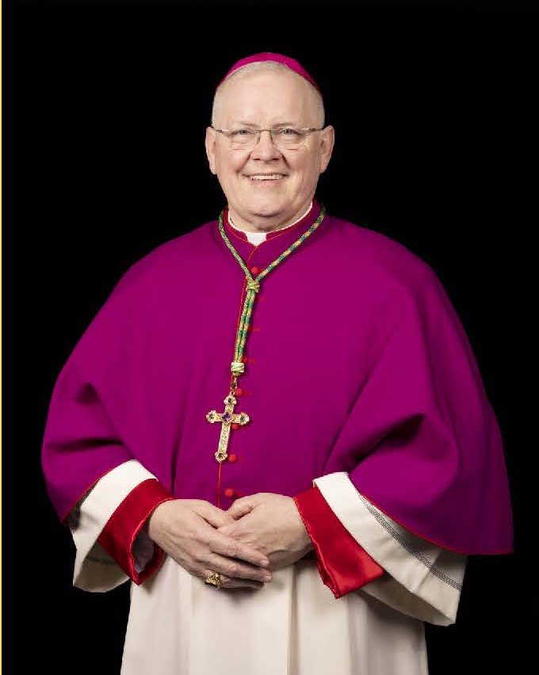

From the first week of creation, God's people have been on the move. Perhaps this is most evident in forty years of desert wandering that followed on being set free from slavery in Egypt. God is always calling us: to take the next step in faith, to go to distant places to see relatives, or to leave behind all that is familiar for the promise of a better life.

As we celebrate National Migration Week, let's remember that God's people are always on the move. And second, God's people are perpetually required to accept, cherish, and defend the dignity of every human being, the sanctity of all human life.

I am pleased to walk in faith alongside our brothers and sisters in the Diocese of Belleville who have come here for refuge, for opportunity, for life. And I promise I'll do all in my power to continue the work of defending the life of all. Let us open our hearts to all God's people, wherever they are, wherever they're from. And in welcoming each one, we will come to know once again what it is to welcome the Lord.

Peace!

National Migration Week 2026

"Even Just One of These Children"
Each year, the Catholic Church in the United States observes National Migration Week, a time dedicated to prayer, reflection, and renewed commitment to our Gospel call to welcome the stranger. During this week, we are invited to reflect on the lives and experiences of migrants, including immigrants, refugees, children on the move, and survivors of human trafficking. As members of one human family, we are called to recognize the God-given dignity of every person and to respond with compassion, hospitality, and hope.
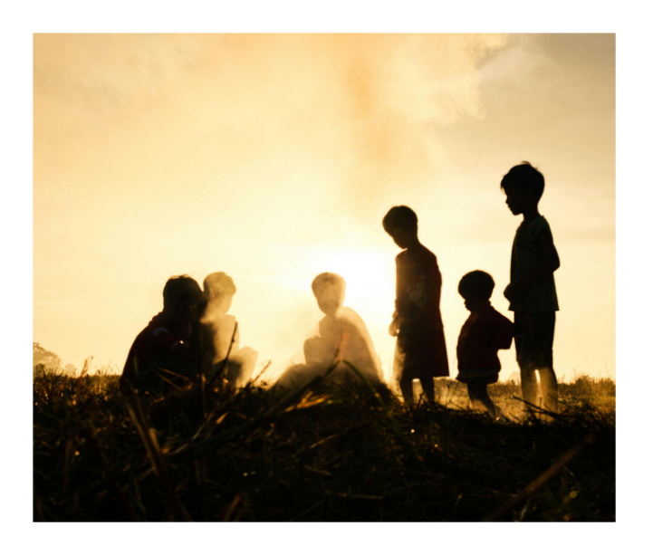

From September 21–27, 2026, Catholics throughout the United States will celebrate National Migration Week, culminating in the 112th World Day of Migrants and Refugees on Sunday, September 27. This year's theme, chosen by Pope Leo XIV, is "Even just one of these children," inspired by the words of Jesus in Matthew 18:5 "Whoever welcomes one such child in my name welcomes me.

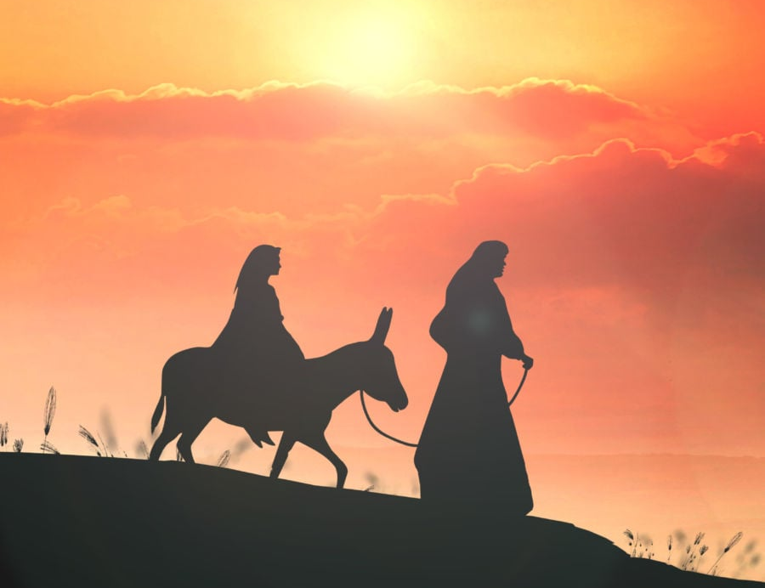

Why Does the Church Care About Migration?
Migration is not only a social or political issue, but also a deeply human and profoundly spiritual reality. Throughout Sacred Scripture, God calls His people to welcome the stranger, care for the vulnerable, and recognize the dignity of every person created in His image.
Jesus Himself experienced displacement as a child when the Holy Family fled to Egypt to escape violence (Matthew 2:13–15). Throughout His public ministry, Christ identified Himself with those on the margins, reminding us, "I was a stranger and you welcomed me" (Matthew 25:35).
The Catholic Church recognizes both the responsibility of nations to regulate their borders for the common good and the God-given dignity and rights of every human person, including migrants, refugees, and asylum seekers. Our response is rooted not in politics, but in the Gospel and in Catholic Social Teaching, which call us to encounter Christ in those who seek safety, hope, and a place to belong.
As we observe National Migration Week, may we open our hearts to prayer, deepen our understanding, and discern how our parishes and communities can become places of welcome, accompaniment, and hope.
Because our faith calls us to prayer, understanding, welcome and accompaniment, National Migration Week gives us an opportunity to put that faith into practice.

Ways to Observe National Migration Week in Your Parish, Community, Organization
National Migration Week offers an opportunity for parishes, schools, organizations, and faith communities throughout the Diocese of Belleville to live out the Gospel call to welcome the stranger. Whether through prayer, formation, fellowship, or acts of service, every community can take meaningful steps to accompany migrants and immigrants with compassion and hope. The following suggestions are intended to inspire local initiatives that foster encounter, deepen understanding, and strengthen our commitment to recognizing the dignity of every person.

Prayer
- Celebrate a Mass with prayers, music, or readings that reflect the diversity of your parish and include special intentions for migrants, immigrants, refugees, and their families. Suggested readings, hymns, intercessory prayers, and sample prayer services are included in this guide.
- Include Prayers of the Faithful for migrants, refugees, and all who are displaced during weekend liturgies.
- Pray the Rosary using A Rosary for Vulnerable Migrant Populations during parish gatherings, ministry meetings, or in your home.
- Host a Holy Hour or Prayer Vigil dedicated to migrants, refugees, and all those affected by forced displacement.
- Celebrate a Prayer Service during National Migration Week using the resources provided in this guide.

Formation
- Share educational resources on migration, Catholic Social Teaching, and the Church's teaching on welcoming the stranger through parish bulletins, websites, social media, or ministry meetings.
- Host a presentation or discussion on migration from a Catholic perspective, inviting knowledgeable speakers or local ministry leaders.
- Share personal testimonies from immigrants, refugees, or those involved in accompaniment ministries to foster understanding and encounter.
- Join Catholics from across the Diocese of Belleville at the National Migration Week Gathering on September 26, 2026. (See registration information included in this guide.)
- Encourage parish book or faith-sharing groups to reflect on Scripture passages and Church teaching related to migration and hospitality.

Hospitality and Service
- Host a multicultural gathering that celebrates the diverse cultures present in your parish through food, music, prayer, and storytelling.
- Welcome newcomers by intentionally inviting immigrant families to participate in parish ministries, faith formation, and community life.
- Organize a collection drive for household items, school supplies, diapers, or other essential needs to support immigrant families in your community.
- Partner with local organizations that provide legal assistance, social services, language classes, or other resources for immigrants and refugees.
- Support the ministries of the Diocese of Belleville Office of Hispanic Ministry and other Catholic organizations that accompany migrants and immigrant families.
- Encourage volunteer accompaniment, such as providing transportation, childcare during parish events, language support, or helping families become connected to parish life.
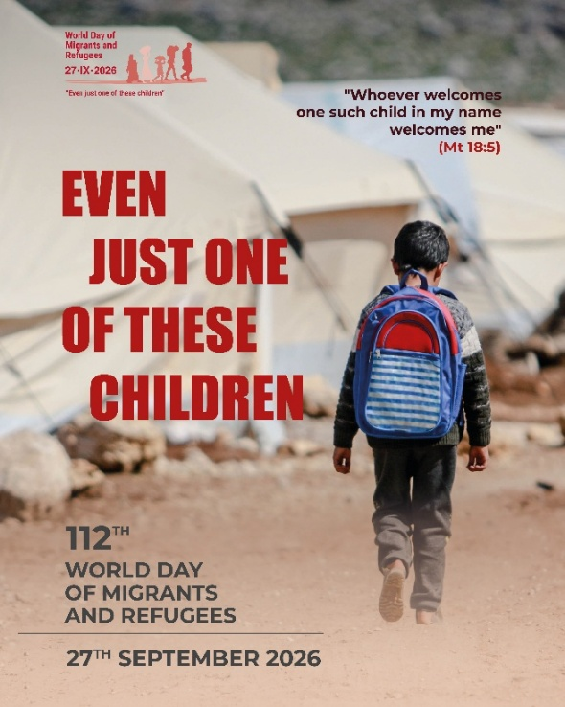
Even Just One: Engaging Children and Youth
During National Migration Week

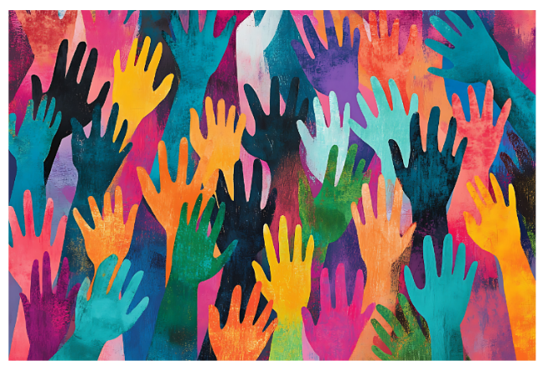

Elementary School
- Read Matthew 18:5 and discuss how Jesus welcomes every child.
- Invite students to write or draw prayers for migrant children and families.
- Create "Welcome" signs in different languages.
- Collect school supplies or children's books for local families in need.
Middle School
- Read the story of the Holy Family's Flight into Egypt (Matthew 2:13–15).
- Discuss why families migrate and how our faith calls us to respond.
- Invite students to write prayers or reflections for children on the move.
- Organize a collection of hygiene items or backpacks for immigrant families.
High School
- Reflect on Catholic Social Teaching and the Church's teaching on migration.
- Listen to a testimony from someone involved in immigrant ministry or accompaniment.
- Participate in a service project supporting local immigrant families.
- Pray for migrants and refugees during a school or parish prayer service.

Prayer Service for Refugees and Migrants

Opening Prayer
Merciful God, we pray for families and individuals who have left or fled their homes, seeking safer and better lives. We lift up to you their hopes, fears, and needs, that they may be protected on their journeys, their dignity and rights may be honored and upheld, and they may be welcomed with open arms into generous and compassionate communities. Amen.

Responsorial Psalm
Psalm 63:2-9


R. My soul is thirsting for you, O Lord my God.
O God, you are my God—it is you I seek; For you my body yearns; for you my soul thirsts, In a land parched, lifeless, and without water. R.
I look to you in the sanctuary to see your power and glory. For your love is better than life; my lips shall ever praise you! R.
I will bless you as long as I live; I will lift up my hands, calling on your name. My soul shall be sated as with choice food, with joyous lips my mouth shall praise you! R.
I think of you upon my bed, I remember you through the watches of the night You indeed are my savior, and in the shadow of your wings I shout for joy. My soul clings fast to you; your right hand upholds me. R.
Reading from Scripture
Leviticus 19:33-34
When an alien resides with you in your land, do not mistreat such a one. You shall treat the alien who resides with you no differently than the natives born among you; you shall love the alien as yourself; for you too were once aliens in the land of Egypt. I, the LORD, am your God.

Reflection
An individual or group reflection on the scripture readings or the needs of refugees and immigrants may take place here.

Petitions
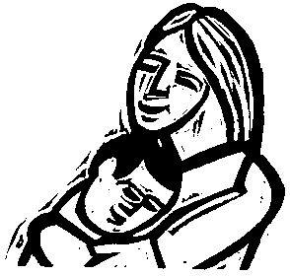
Trusting that God’s mercy is revealed in love for those who hurt or are in need, let us now lift up prayers for migrants and refugees, saying: “Hear us, God of mercy.”
That migrants and refugees may receive compassionate and practical help and find comfort from their sorrow and fear, we pray: R.
That unaccompanied migrant children might be kept safe and reunited with families and loved ones, we pray: R.
That governments will address the root causes of migration and implement fair and compassionate immigration policies, we pray: R.
That all people of good will may stand in solidarity with migrants and refugees and have the courage to welcome every newcomer, we pray: R.
That peaceful solutions may be found to the conflict, injustice, and violence that forces people to flee, we pray: R.
That effective responses to climate change may halt the flooding, drought, and natural disasters that lead to migration of the poor, we pray: R.
Other intercessions may be offered here.
Our Father…
Closing Prayer
Loving God, you create every person in your image and unite us all in one human family. As our brothers’ and sisters’ keepers, fill us with courage and compassion, that we might meet the hardships of migrants and refugees, not with silence and indifference, but with generous acts of mercy, welcoming every stranger as Christ in our midst. Amen.

Sign of Peace
All present may share an appropriate sign of peace.

© 2026 Catholic Charities USA. All rights reserved.
Readings, Hymns, Intercessions and Scripture Reflections for Mass or Prayer Service

Readings
- Old Testament: Leviticus 19:33-34 (Treat the foreigner as your own citizen).
- Psalm: Psalm 146:7-10 (The Lord protects the stranger) or Psalm 96.
- Psalm 121 (Our Help Comes from The Lord)
- New Testament: Hebrews 13:1-3 (Do not forget to show hospitality) or Romans 12:10-13.
- Gospel: Matthew 25:35-40 ("I was a stranger and you welcomed me") or Luke 10:25-37 (The Good Samaritan).

Hymns
- Gather Us In by Marty Haugen
- All Are Welcome by Marty Haugen
- Be Not Afraid by Bob Dufford
- The Summons by John L. Bell
- City of God by Dan Schutte

Intercessory Prayers
- For all bishops in our Church, that they may be encouraged by our prayers and support to lead God’s people in building a culture that respects the human dignity of all migrants, we pray to the Lord,
- For all Catholics, that God inspire them to take action in their local communities to support and protect migrants and to advocate on their behalf, we pray to the Lord,
- For unaccompanied migrant children, that God protect them on their journey and safely reunite them with their families, we pray to the Lord,
- For our neighbors, coworkers, friends, fellow Christians, and all people, that they may grow in their awareness of the issue of migration and become a voice in the public square calling for greater protections for these populations, we pray to the Lord,
- For migrant workers, that they may labor in safe and just conditions, and that we who benefit from their labor may be truly grateful for what they provide, we pray to the Lord.
- For migrants, refugees, and all other strangers in our midst, that they may find strength in our concern for justice and feel the warmth of our love, we pray to the
Lord,

Government Officials
- For the President of the United States and all government leaders: that the Son of God, who became human, will open their hearts and minds so they may recognize the great dignity of human persons, and support legislation that protects vulnerable populations in our midst, we pray to the Lord,

- For policymakers in our nation, that God grant them the wisdom and compassion to enact laws that provide greater protection for all migrant populations, we pray to the Lord,

- For policymakers in our nation, that they will provide the support to migrant populations who yearn for a new beginning, we pray to the Lord.

Reflecting on the Sunday Readings

The Gospel – Matthew 21:28–32
- Jesus tells us that what we do matters more than what we say.
- Where do our actions show that we truly welcome and care for others?
- What might it look like to say “yes” to a migrant child or family in our community?

The Second Reading – Philippians 2:1–11
- St. Paul reminds us to have the mind and heart of Christ.
- Jesus calls us to look beyond our differences and see the person in front of us.
- What changes when we see a migrant child or family first as our brother or sister in Christ?

The First Reading – Ezekiel 18:25–28
- God calls us to turn away from what is wrong and choose what is right.
- Are there times when we see someone in need but choose not to get involved?
- How can we respond with greater compassion and justice?

This Year’s Theme – “Even Just One of These Children”
- Jesus reminds us that every person matters to God.
- We don't have to solve every problem. Sometimes we are simply called to help one person, one child, or one family.
- What is one thing our parish can do to be a place of welcome and hope?
Migrant Stories: I Don’t Know How to Be a Dad Through a Screen

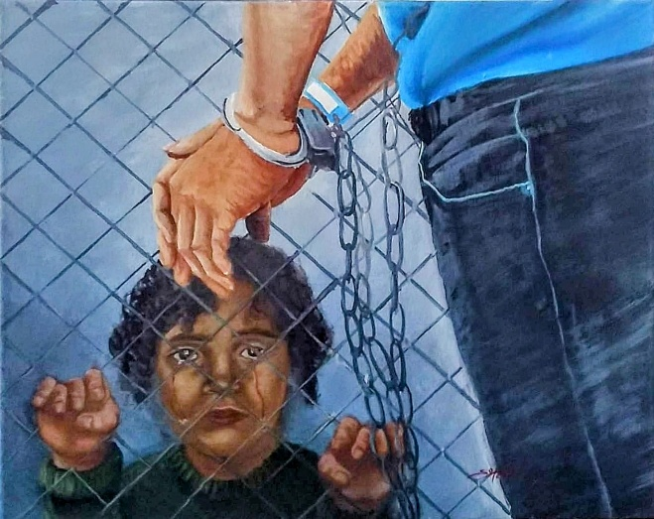
June 15, 2026

Kino Border Initiative

“The thing that hurts me most isn’t losing my job or my home. The thing that hurts me most is not being able to show up on a Friday afternoon with donuts for my kids.”

Rolando told us this while sitting in the government shelter in Nogales, Sonora, far from Phoenix, the city where he built his life for more than 35 years. It was there that he started a family with his wife, who is also from Guerrero, Mexico. It was there that their four children were born and raised. It was there that he worked for years doing maintenance and landscaping for corporate buildings, and at night as a school custodian.

Before arriving in the United States, Rolando had already experienced displacement. When he was 18, he left Guerrero after criminal groups forced his family from their home and took the land his father and grandfather had passed down. From that moment on, migration became a means of survival.

In Phoenix, he found stability. Or at least he thought he had.

Rolando’s life was deeply rooted in his community. He knew teachers, neighbors, and families from the school where he worked. He understood the importance of parents being present in their children’s lives because he always tried to be present in his own.

For Rolando and his family, Fridays were a simple but sacred tradition: donuts, coffee, and a movie together at home after school and work.

Rolando was detained while driving home. A traffic officer pulled him over and later contacted ICE. Although he showed documents for his vehicle, the officer said he did not believe him and decided to detain him. Rolando was transferred through the detention centers in Florence and Eloy, Arizona, before being deported to Nogales.

From that moment on, his family’s life was divided by a border.

Ten days after his deportation, his oldest daughter was set to begin the college admissions process. One of his sons was about to graduate from middle school and prepare for high school. In their family, these milestones were always celebrated together: tacos, grilled meat, music, and photos to mark the transition from one stage of life to the next.

“I always dreamed of being there for every achievement. I wanted them to study and become great people. My daughter wants to be a lawyer. My sons have dreams. And now I don’t know how to help them from here,” he shared.

The distance changed more than where he lives.

It changed the way he can be a father.

Now his children can only see him through video calls. His wife, Adelia, carries much of the emotional and financial burden on her own while Rolando tries to figure out how to parent from afar, how to remain a present father when he can no longer take them to school, sit with them after class, or hug them during important moments.

“People think they deport one person, but in reality, they separate an entire family,” he says.
At Kino, we hear stories like Rolando’s every day. Stories in which deportation interrupts not only careers and life plans, but also family relationships, educational opportunities, and the emotional stability of children and teenagers.

The forced absence of a parent has profound consequences, especially during key moments in a child’s development, when they need guidance, stability, and presence the most.

“I don’t know how long it will be before I can hug them again,” he told us as we said goodbye.

“But every day I try to remind them that I’m still their dad, even if now it’s through a screen.”
As immigration policies continue to separate families, Rolando is trying to hold on to something that should never depend on borders or detention centers: a father’s right to be part of his children’s lives.
Reflection
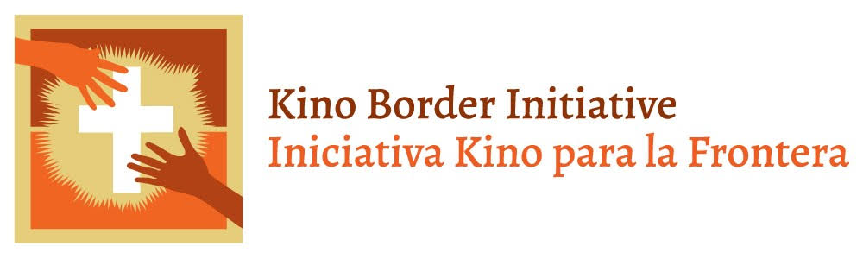
How might our parish become a place of hope for families who are experiencing separation, uncertainty, or displacement?

A Catholic Guide to Migration
What does the Catholic Church teach about migration?

Every person has inherent dignity.
Every person is created in the image and likeness of God. Our response to migrants and refugees must begin with respect for the dignity of every human person.

People have a right to seek safety and a better life.
The Church recognizes the human desire and right to seek conditions that allow individuals and families to live with dignity.

Nations have a right to regulate their borders.
The Church recognizes the responsibility of governments to protect their borders and promote the common good. This responsibility must always be exercised with respect for human dignity.

Families should be protected and kept together.
Because the family is the foundation of society, policies and practices should seek to protect family unity, especially the well-being of children.

Those who are most vulnerable deserve special care.
The Gospel calls us to pay particular attention to those who are poor, displaced, excluded or vulnerable, including migrants and refugees.

Catholics are called to welcome and accompany.
Our response is not limited to charity. We are called to encounter our migrant neighbors, listen to their stories, accompany them, and work for a society where human dignity is respected.

Resources for Prayer, Formation, and Action

Prayer and Liturgical Resources
- National Migration Week Resources (USCCB)
- World Day of Migrants and Refugees (Vatican)
- Prayer Service for Migrants and Refugees
- Rosary for Vulnerable Migrant Populations
- Praying the Rosary with Stories of Immigrants: The Sorrowful Mysteries
- Stations of the Cross: Walking with Immigrant Stories
- Prayer for Migrants and Refugees
Scripture and Catholic Teaching
- Scripture and Migration
- Migration and Catholic Social Teaching
- Strangers No Longer: Together on the Journey of Hope
- Papal Teaching and Migration
- Migration and the Social Doctrine of the Church
- Catechism of the Catholic Church (No. 2241)
- Mass Deportations and Catholic Teaching | Kristin Heyer 2026

Children, Youth and Families
- Parish Activities to Help Immigrants, Migrants, Refugees and People on the Move
- Catholic Action Toolkit: Welcoming Migrants & Refugees
- Catholic Relief Services Resources
- National Migration Week Toolkit USCCB/JFI

Advocacy and Pastoral Accompaniment
- Parish-Based Immigrant Justice Committee Planning Guide
- Parish Toolkit Supporting Immigrants in a Time of Need (CLINIC 2026)
- How to Prepare a Faith Rally and Vigil to Stand with Migrants
- And They Shall Know us by Our Love (Catholic Charities USA)
- Ten Things You Can Do to Accompany Undocumented Immigrants
- Diocese of Belleville Office of Hispanic Ministry

Prayer of Commitment
Lord Jesus,
As we conclude National Migration Week, send us forth to welcome the stranger, accompany those in need, and recognize Your presence in every child, every family, and every person seeking hope. May our parishes throughout the Diocese of Belleville become places where all are received with compassion, dignity, and love. Amen

May our prayer become welcome, our welcome
become accompaniment, and our accompaniment become action.
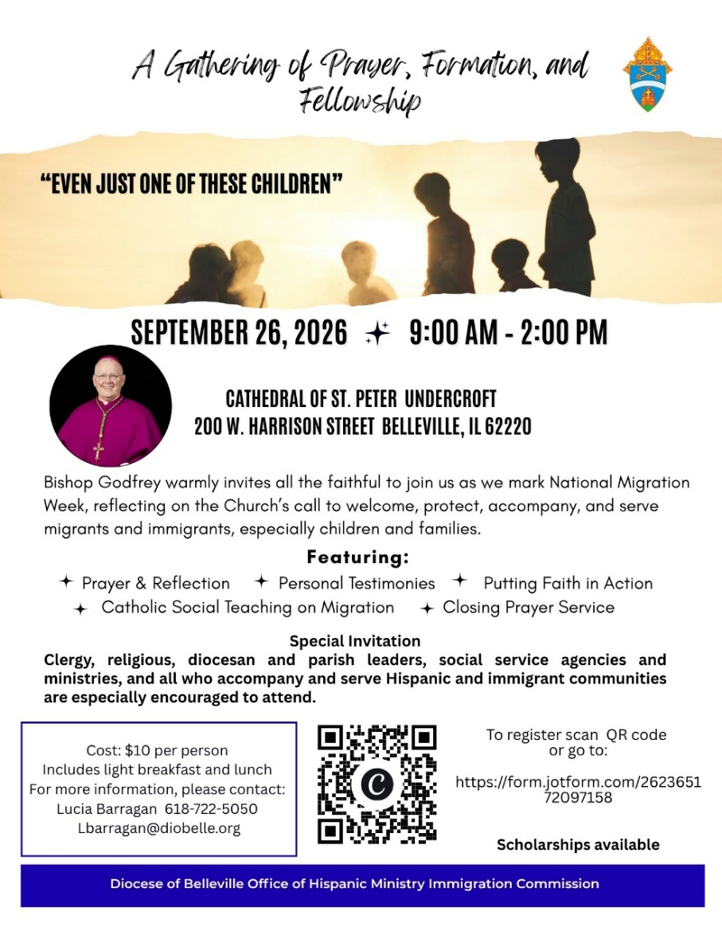

Diocese of Belleville Office of Hispanic Ministry
National Migration Week 2026

